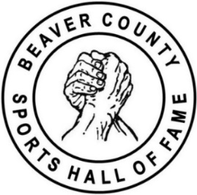 | Beaver County Sports Hall of Fame  TICKET RESERVATION FORM |  | 50  YEARS  1975-2025
CLASS of 2025  INDUCTEES  Jonathan Baldwin  Football, Aliquippa  David Girardi  Coaching, Geneva College  Lance Jeter  Basketball, Beaver Falls  Adam Liberatore  Baseball, Blackhawk  Larry Milosh  Coaching, Central Valley  Derek Moye  Football, Rochester  Jeff Nixon  Coaching, New Brighton  Brian Omogrosso  Baseball, Blackhawk  Joseph Palumbo  Football, Beaver  Josh Sharpless  Baseball, Freedom  Mike Zmijanac  Coaching, Aliquippa  ________________________  Scan the QR code below to visit the  Hall of Fame website   | Beaver County Sports Hall of Fame  50th Anniversary Banquet  Saturday, May 17, 2025  The Club at Shadow Lakes  2000 Beaver Lakes Boulevard, Aliquippa, PA 15001  Doors open at 3:30pm Dinner at 4:30pm
 |  | Number of individual tickets, at $50 per ticket
 |  | Number of tables of ten seats, at $500 per table
 |  | Name of the person ordering tickets
 |  | Address to mail the tickets
 |  | Phone number
 |  | Email address
Make checks payable to "Beaver County Sports Hall of Fame, Inc." and mail to
Janet Zigerell, 533 Phillips Street, Baden, PA 15005.

Tickets will be mailed upon receipt of the reservation form and payment. The last day to request banquet tickets is Saturday, April 26, 2025. Please make your reservations early! No tickets will be sold at the door.

If you have questions, please contact Hall of Fame Secretary Janet Zigerell at 724-561-3226 or at jzigerell@gmail.com.

Thank you!

